Preapare maven project

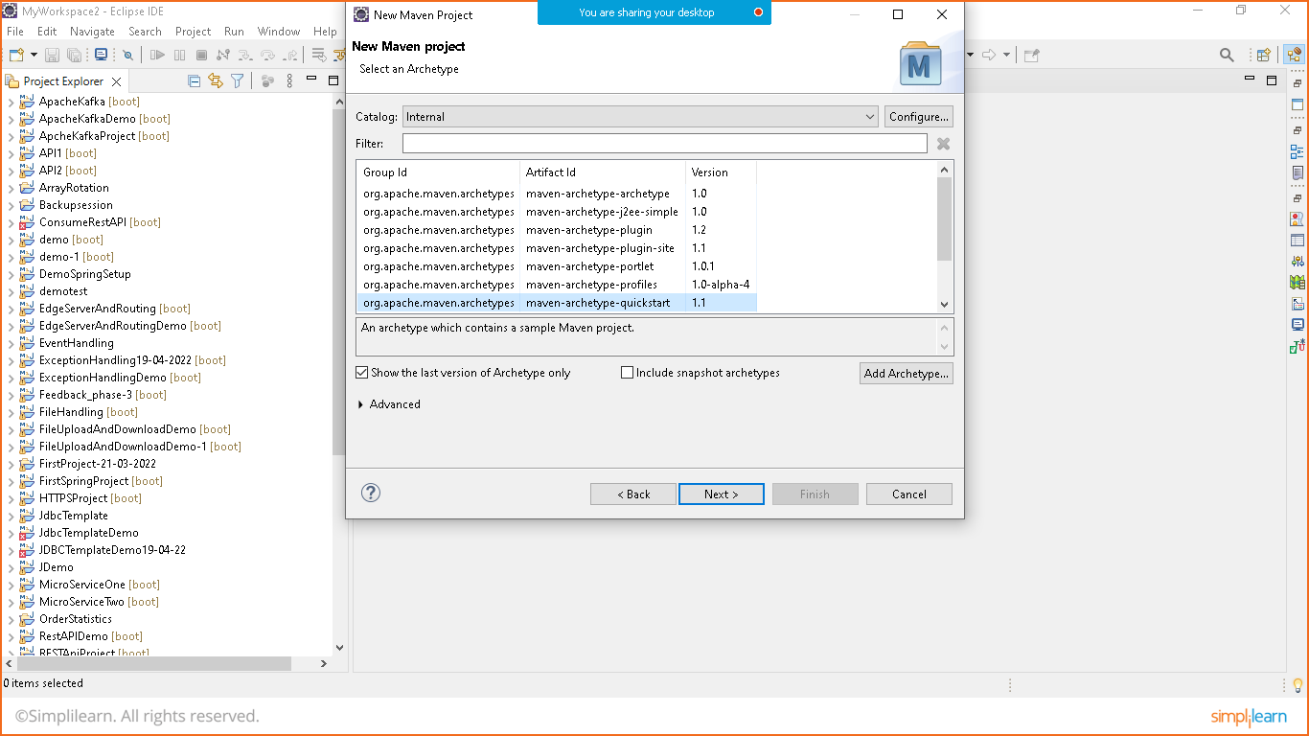

Provide information

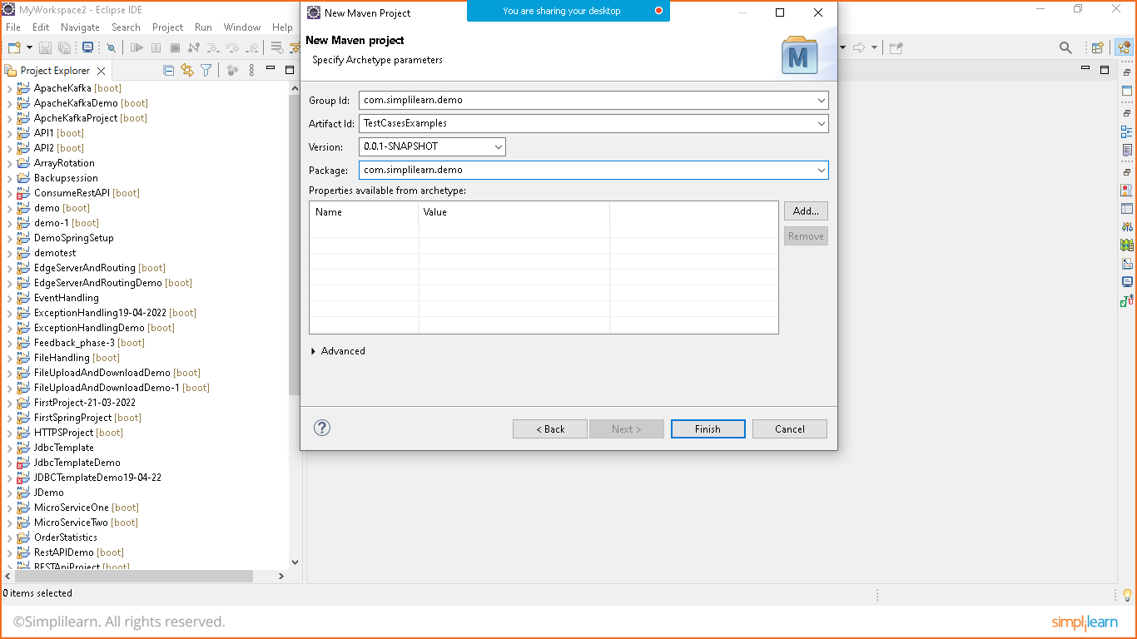

Now go to the pom.xml file

Delete the existing dependency

Add two dependencies

1. Junit Jupiter
2. Junit Engine from maven repository

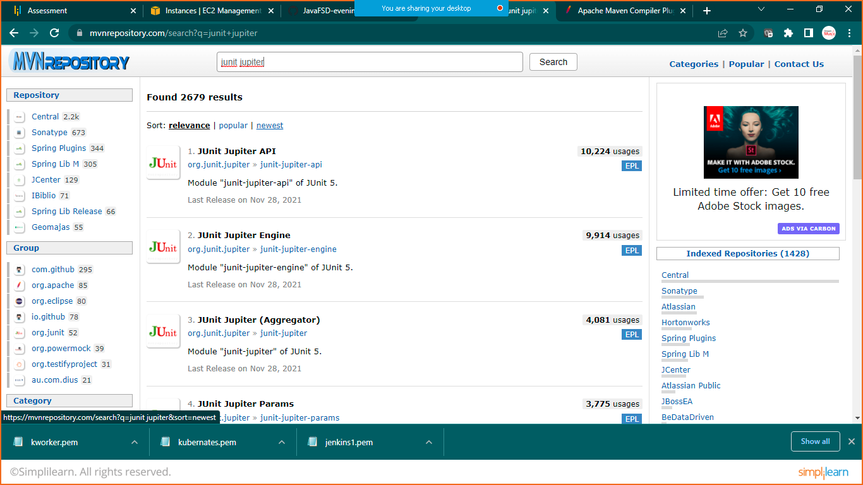

Copy the dependencies and paste it in pom.xml file

Save the file and update maven project

Now you will see an error in the project

So delete the app.test and app.java file from the project

Now for junit -5 we need a maven compiler plugin download it from google

Link: <https://maven.apache.org/plugins/maven-compiler-plugin/examples/set-compiler-source-and-target.html>

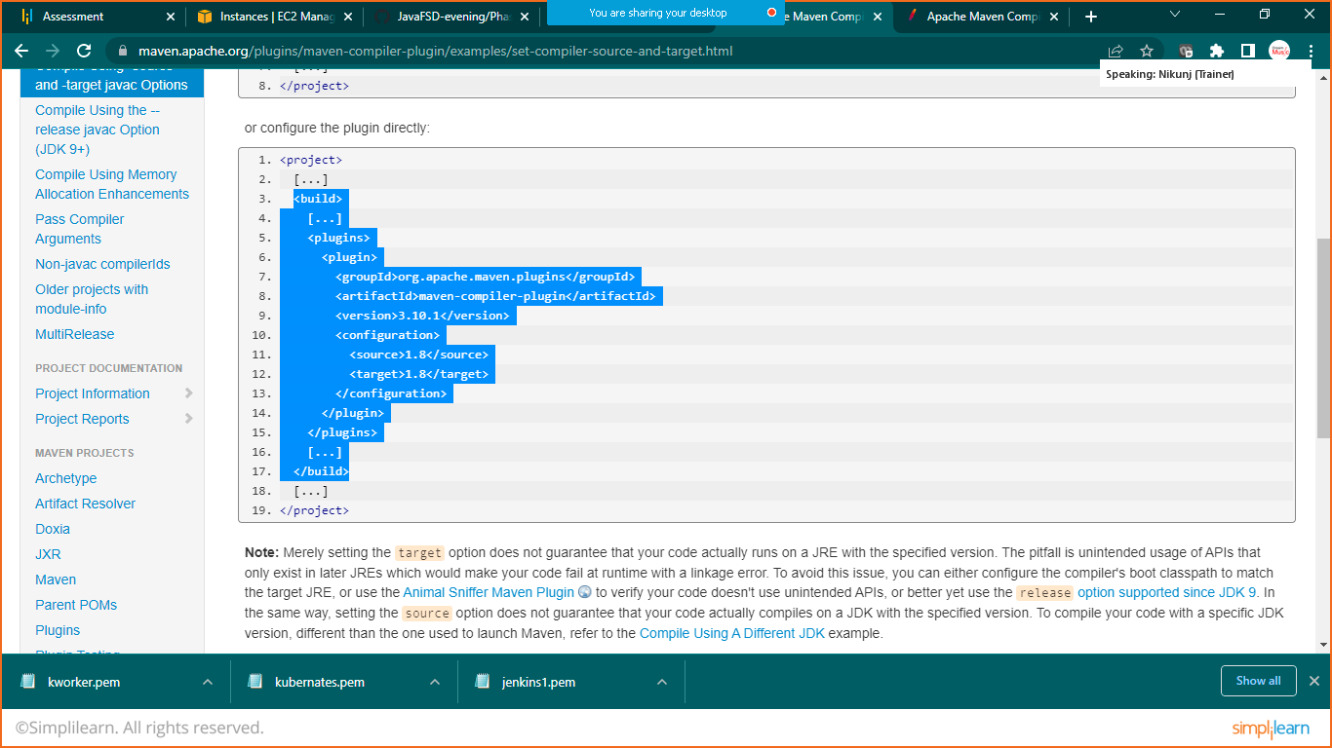

Copy the selected items and paste it in pom.xml file as shown below

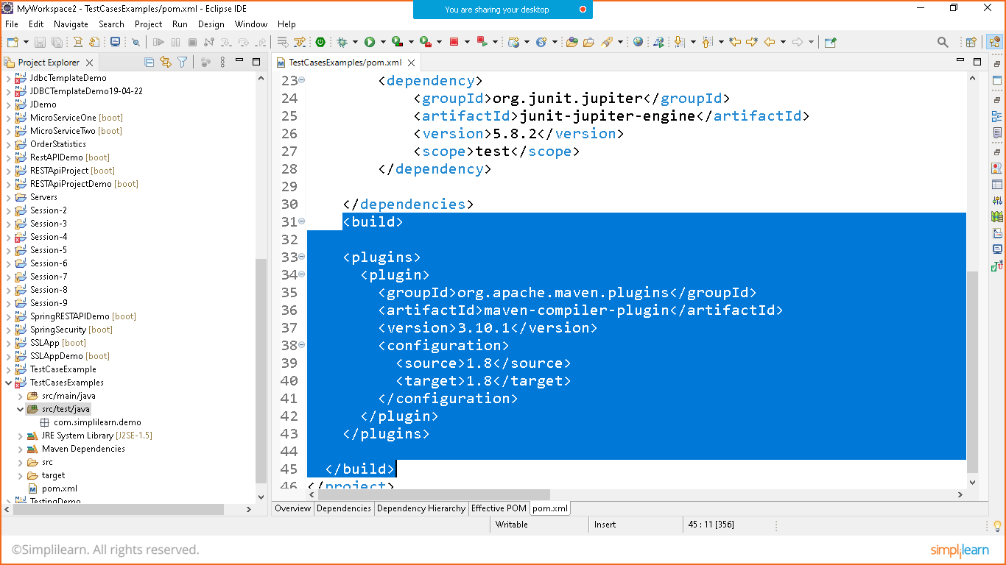

Update maven project

Goto src/test/java right click on it create junit test case

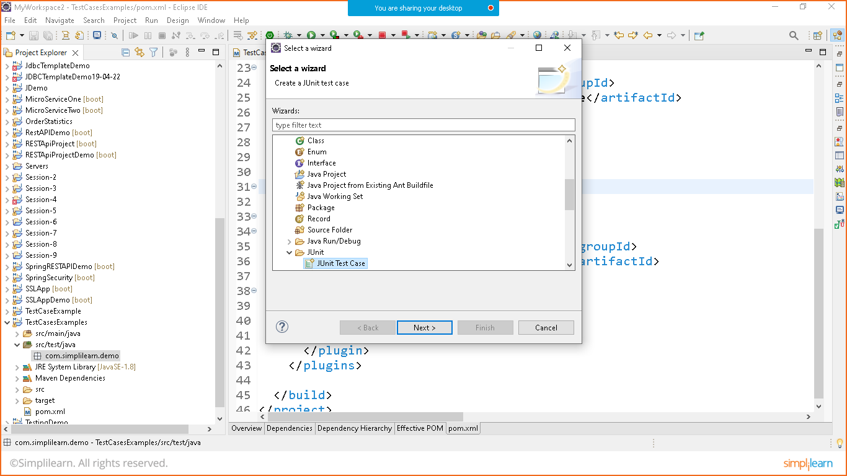

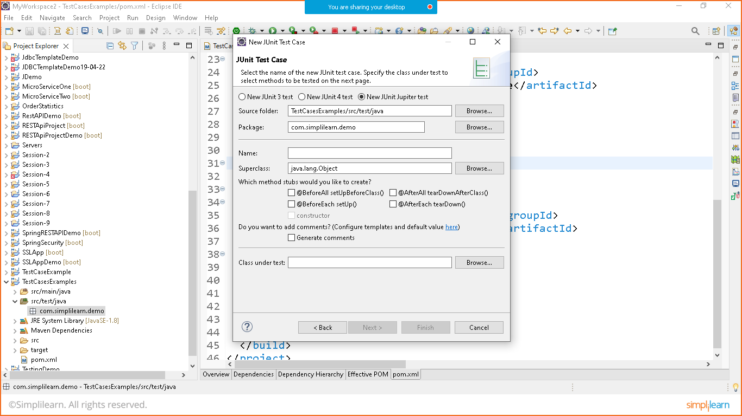

Give the name of test and we are ready to write test cases

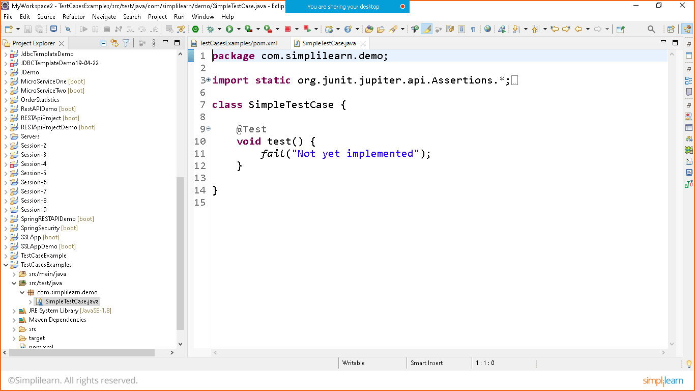

Now lets understand the flow logic of testcases

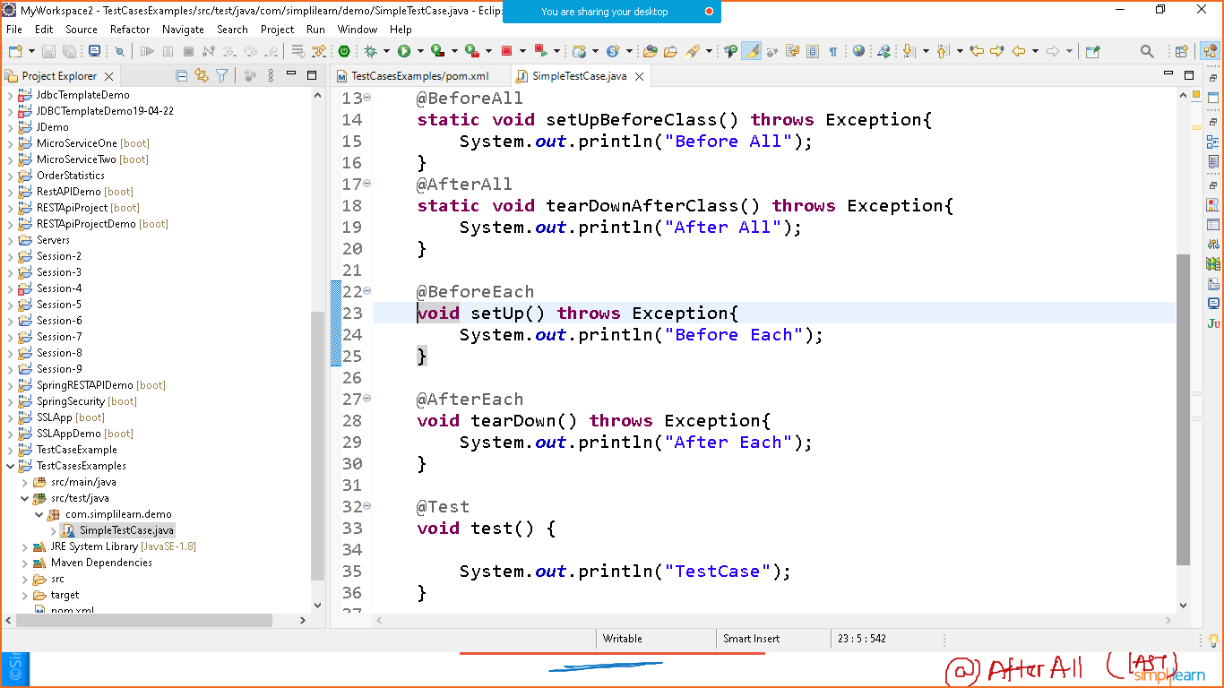

Right click on the testcase and run as joint testcase

